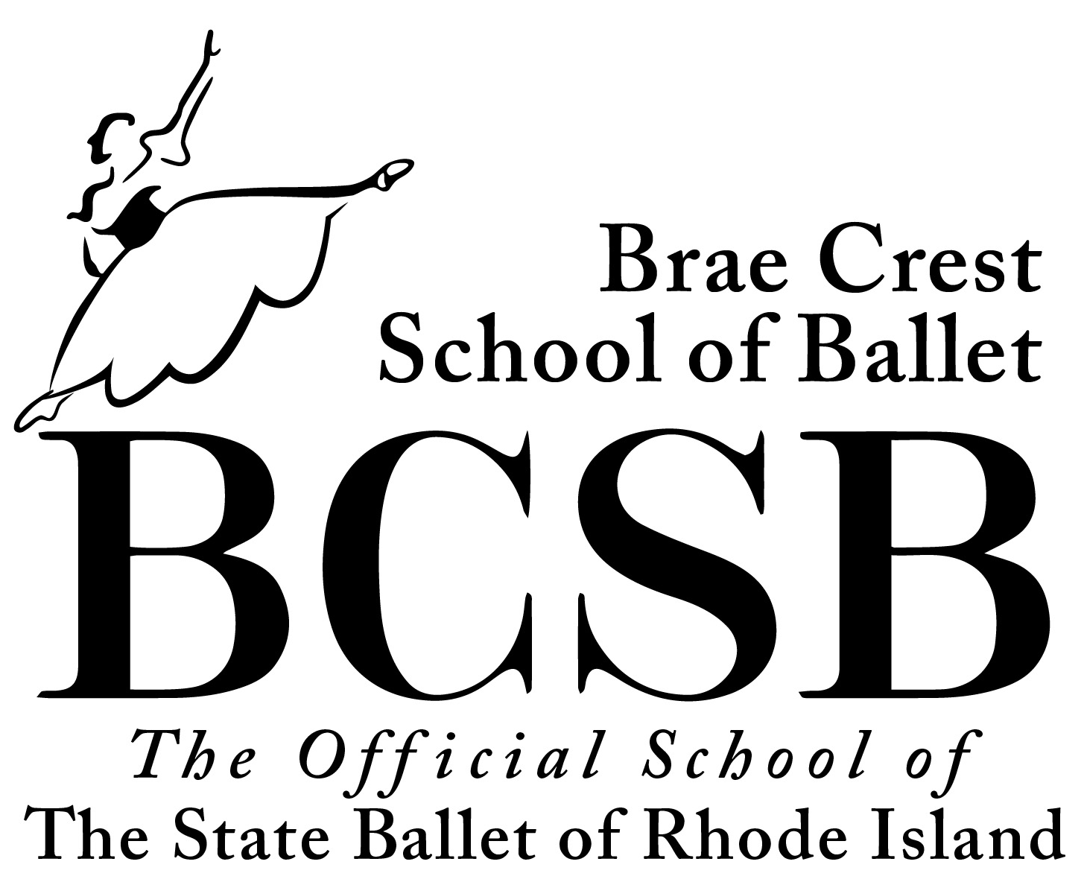
Brae Crest School of Ballet
Official School of The State Ballet of Rhode Island
Founded in 1958 by the Marsden Family

CLASSICAL BALLET: TECHNIQUE • POINTE • PAS DE DEUX ● CHARACTER ● MODERN DANCE
Pre-Primary • Beginner • Intermediate • Advanced • Professional

Faculty & Staff: Herci Marsden, Ana Marsden Fox, Shana Fox Marceau, Ashley Harrington,
Lori Broess, Ashley Marsden, Mark Marsden, Richard Anton Marsden, Dujko Radovnikovic

52 Sherman Avenue • P.O. Box 155 • Lincoln, RI 02865 • 401-334-2560 • www.stateballet.com • braecrest@stateballet.com

============= Summer Ballet Program 2026 =============
Five Weeks, July 6th through August 7th

SUMMER TUITION FEES____________________________________________________________________
Intermediate  Intermediate | ---  –– | One Class per week for 5-week term (5 hours) ……………………………………….….… $100  Two Classes per week for 5-week term (10 hours)………………………………………….… $180
Intermediate | –– | Three Classes per week for 5-week term (15 hours)…..………………………………............... $255
Intermediate | –– | Four Classes per week for 5-week term (20 hours)..................................................................... $300
Advanced  Advanced | ––  --- | One Class per week for 5-week term (7.5 hours) ……………………………………...…… $150  Two Classes per week for 5-week term (15 hours)…………………….…………………….... $270
Advanced | –– | Three Classes per week for 5-week term (22.5 hours) ……………………….……………….... $385
Advanced | –– | Four Classes per week for 5-week term (30 hours)………………………………...………..… $450

Individual Intermediate Drop-In Class …………. $25
Individual Advanced Drop-In Class ……………. $35
PRIVATE LESSON --- One Pupil …………….. One ½ Hour: $40 ---------- One Hour: $80
Semi-Private ………….. One ½ Hour: $70 ---------- One Hour: $90

REGISTRATION AND PAYMENT:
Students must register in advance for each term. [See slip at bottom of page]
Please sign, date and submit with payment. Partial payments may be arranged before start of term. Class sizes are limited.
Cash or Checks Made Payable to: Brae Crest School of Ballet
For any returned checks, there will be a Service Charge of $30.00.
No refunds will be given. Instead, students are able to make up missed classes in another available class. Please make up as soon as possible and with permission from Miss Ana. No make-up classes allowed in a new term without being a registered student in the term.
Please note: 24 hour advanced notice is required when canceling a private lesson and the new appointment is encouraged.
DRESS CODE: Intermediate and Advanced Females: pink tights and pink technique and pointe ballet shoes with leotard of any color. Skirts optional. No shorts. All girls wear hair up off of neck in a bun. Males: All male students are required to wear male attire such as black footless tights, a tee shirt, dancebelt, white ballet shoes and white socks. Hair pulled back.
No jewelry, including smart watches that could distract or become dangerous. A dress code ensures that all dancers will have adequate mobility and appropriate coverage during class. Improper clothing can impact technique, precision, ability to grip the floor, and visibility. This is especially important to remember when performing in a group and with a partner.
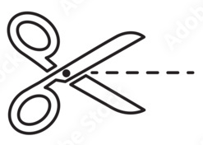
Brae Crest is not liable for any injury that may occur in the studio or on premises.
--------------------------------------------------------------------------------------------------------------------------------------------
REGISTRATION SLIP: BCSB Summer 5-Week Ballet Program 2026
______________________________________________________ ______________________________________________________
Student Name Class Schedule
_________________________ __________________ ______________ ____________________________________
Deposit Amount or Paid In Full Amt. Cash or Check # Balance Due Date & Signature
Deposit or Payment in Full is required prior to entering class, recommended by June 1st. Class Space Limited.

